# **Stress Management in the Workplace – stress source, physical and emotional symptoms, coping mechanism.**

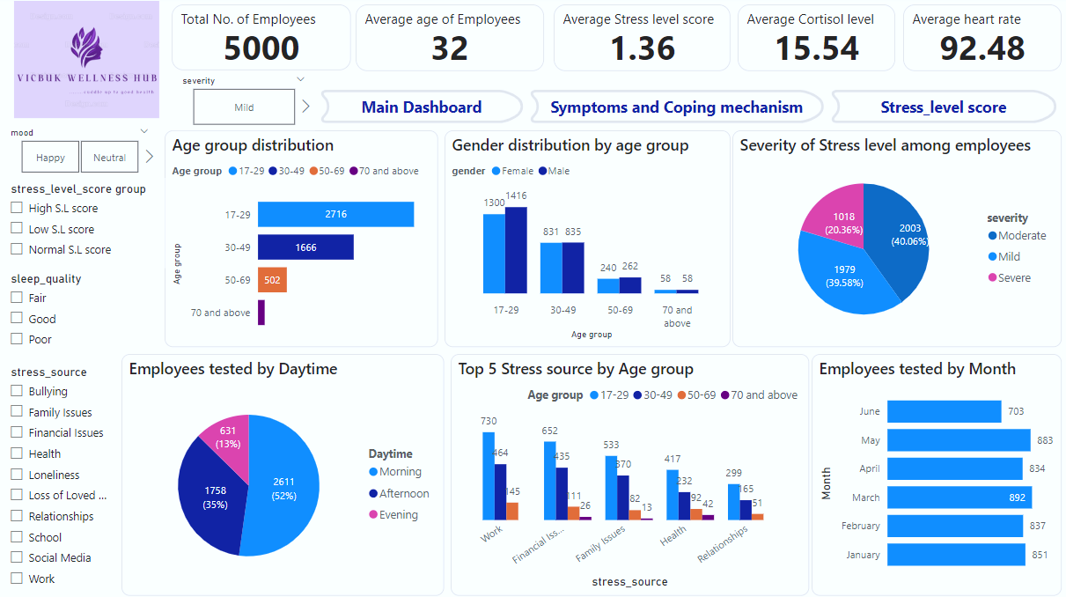

The Stress Management Report provides a thorough analysis of the Stress level dataset, which includes stress source data, the symptoms exhibited by workers – both physical and emotional, the coping mechanism, severity of stress across age groups and time periods, as well as other factors. The aim of this analysis is to uncover trends, pinpoint top stress sources, the severity of stress and coping mechanisms, and use this information to empower data-driven decision-making on stress management and/or reduction among workers in order to improve productivity.

# Introduction

Vicbuk Wellness Hub is a wellness company that helps organizations manage employee stress levels. The company collects data on employee stress levels through surveys and monitoring systems to create a comprehensive Stress Management Dashboard that provides key insights into employee stress levels across different departments, time periods, and other factors. This dashboard will help HR and management make informed decisions about stress reduction programs.

In this report, we’ll be diving into Vicbuk Wellness Hub’s data to find useful insights by looking at trends in the stress source, behavioral patterns of employees based on physical and emotional symptoms, as well as, coping mechanisms employed to get over stress.

# Problem Statement

The client noticed a decline in productivity and health of workers in the organization. A quick session with the workers pointed out stress as the primary source of the decline hence, the intervention to identify the source of stress, the severity, heart rate, mood or disposition to work that may require attention, and evaluating ways to reduce stress among workers in order to increase productivity, improve the health of workers and in turn yield more revenue.

# Objectives

From the dataset provided gathered from the client’s database, here are some questions which will channel the analysis into finding suitable ways to alleviate stress in the workplace.

* What stress source is more prevalent among the different age groups represented?
* Could there be a correlation between the physical symptoms exhibited and the mood of workers?
* Is there a difference between the stress levels of workers based on the time the test was done?
* Is there a possibility that the sleep quality is a determinant of the severity of stress in workers?
* Can the coping mechanisms employed by workers by incorporated in the workplace?

# Data Overview

The dataset is a table with 18 columns that bounds various aspects that identify stress causes and symptoms. These columns provide information which can be grouped as follows:

1. **Employee Data:** Demographic information about employees, including names, date of birth, gender, and unique identifiers (id).
2. **Test Data:** records of the test date and time.
3. **Stress Data:** Comprehensive details about:

* Source of stress: the primary cause of stress for the individual.
* Physical symptoms: The symptoms exhibited physically due to stress.
* Emotional symptoms: The emotional symptoms experienced due to stress.
* Coping mechanism: Methods used to cope with stress.
* Duration of stress: The duration of stress experienced in days.
* Severity: The severity of the stress experienced.
* Stress score: The individual’s perceived level of stress.

1. **General wellbeing:** Information about:

* Heart rate: the heart rate of the individual at the time of reporting in beats per minute.
* Cortisol levels: the cortisol level of the individual at the time of reporting Aµg/dL.
* Sleep quality: the quality of sleep reported by the individual.
* Mood: the mood of the individual at the time of reporting.

# Data Transformation

The dataset was imported into SQL and data cleaning and transformation was done to prepare the data for exploration and modeling. The data transformation steps were performed using the appropriate SQL QUERY and they include:

* **Handling Missing Values:** missing values were replaced with appropriate placeholders and incomplete records were removed after they were confirmed to be duplicates.
* **Removing duplicates:** The first step was to create a duplicate table including a new column for row numbers. The row number helped to check for and delete duplicates.

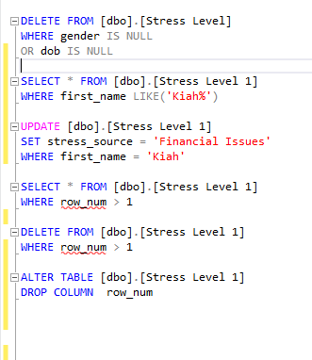

* **Correcting Inconsistent Data:** Standardize formats for date fields to ensure consistency.

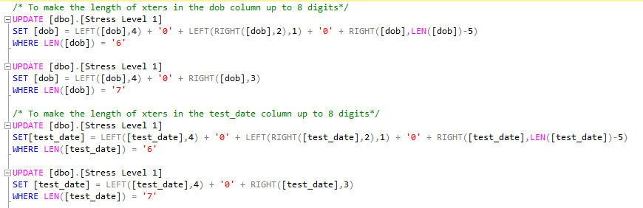

* **Converting Data Types:** Ensured fields are in the correct data type, such as converting dates to datetime format.

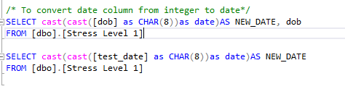

After these steps, the table was loaded in power query and further cleaning and transformation was done which include:

* **Correcting Spellings and Connotation:** Used descriptive names for tables and columns to enhance clarity such as changing data in the gender column from M to Male and F to Female.
* **Documenting Cleaning Steps:** Maintained a detailed record of all data cleaning steps for reproducibility and transparency.
* **Addition of Conditional Columns:** DAX was used to create new columns such as the daytime, age, age group, and the stress level score group columns.

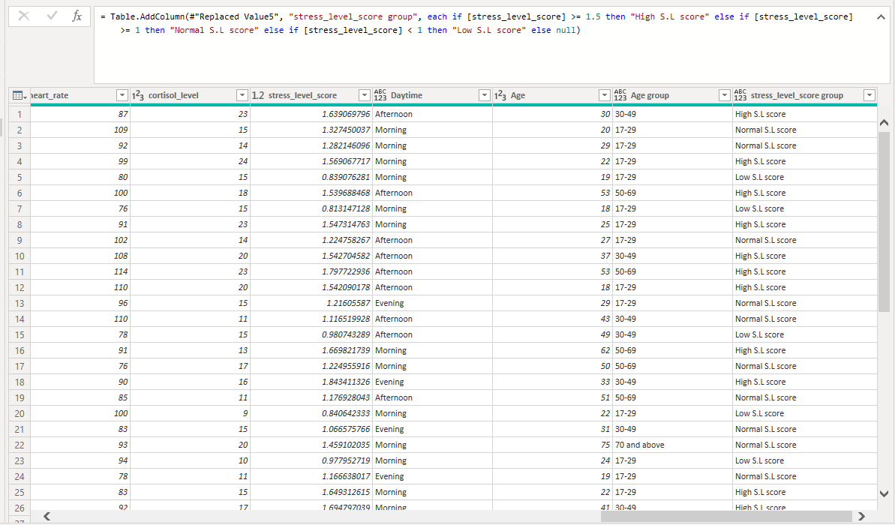

An example of the DAX statement used for the stress level score column

# Exploratory Data Analysis (EDA):

Before moving ahead to get all the details, it is important to do Exploratory Data Analysis (EDA) on the dataset. EDA means taking a good look at the data to understand its main characteristics. This is done by summarizing how the data behaves and making pictures to show any important trends. This first glance helps us to figure out how the data is organized and what is in it, so we can find deeper insights later.

# Key Performance Indicators (KPIs):

KPIs were added to tell us how the employees are doing. In this analysis, performance was based on key metrics like:

* **Total No. of Employees:** The organization has a total of 5,000 employees.
* **Average age:** The average age of employees is approximately 32 years.
* **Average stress level score:** This being the actual measure of stress had the average being 1.36.
* **Average cortisol level:** Cortisol is a hormone released during stress and the average level for all employees tested is approximately 15.54Aµg/dL.
* **Average heart rate:** The average heart rate is 92.48 beats per second.

# Employees Analysis Report:

This report provides a detailed analysis of employee performance and distribution. The analysis includes: Count of employees by age group, gender distribution for employees, Top 10 Employees by average stress level score, employees tested by month and daytime, stress source across age groups.

**Employees by Age Group**

* 17-29: Made up 2716 of the total employee count.
* 30-49: Made up 1666 of the total employee count.
* 50-69: Made up 502 of the total employee count.
* 70 and above: Made up 116 of the total employee count.

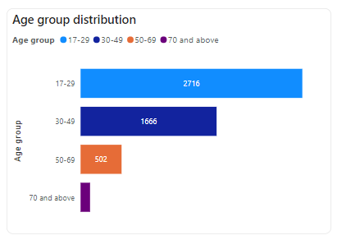

The total number of employees segmented by age group shows that people within the age range 17-29 make up the largest part with 2,716 individuals which is 54.32% of the total count. The age range 30-49 has 1,666 employees which is 33.32% of the total count. The age group 50-69 contribute a smaller but still substantial amount of 502 employees which is 10.04% of the total count, while those who are 70 and above contribute the least with a count of 116 making up 2.32% of the total count. This suggests that the middle-aged (17-29) and young adults (30-49) demographics contribute to a larger part of the workforce, which will likely contribute to higher productivity in the organization.

**Gender by Age Group:**

* Male Employees: Made up 2,571 (51.42%) of the total number of employees.
* Female Employees: Made up 2,429 (48.58%) of the total number of employees.

The 2,571 male employees had the following count in age groups segmentation. 1,416 belonged to the 17-29 age group, 835 are in the age group 30-49, 262 are in the 50-69 age group, and 58 have ages in the group 70 and above.

The 2,429 female employees had the following count in age groups segmentation. 1,300 belonged to the 17-29 age group, 831 are in the age group 30-49, 240 are in the 50-69 age group, and 58 have ages in the group 70 and above.

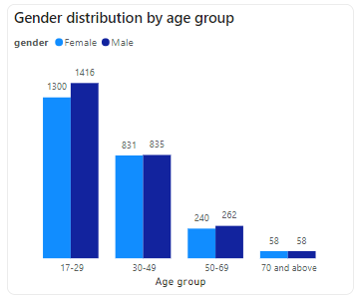

The distribution between male and female employees is almost even, with males slightly ahead. This balanced split indicates gender inclusion in the organization. Stress maintenance strategies can therefore be inclusive, targeting both male and female employees without significant bias towards either group.

**Top 10 Employees by Average Stress Level Score**

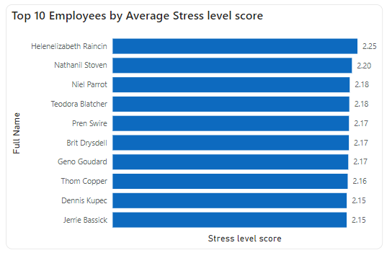

The employee with the highest average stress level score of 2.25 is Helenelizabeth Raincin, closely followed by Nathanil Stoven with an average score of 2.20. The least being Jerrie Bassick and Dennis Kupec, with an average score of 2.15. Three employees have an average score of 2.17 which could be a pointer to look into their stress sources and other factors to see if there is a likely relationship which can aid coming up with a suitable solution.

**Employees Tested by Daytime**

Morning: 2,611 employees

Afternoon: 1,758 employees

Evening: 631 employees

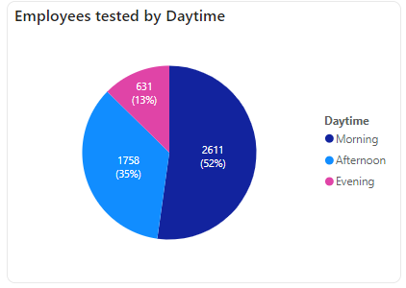

Most of the employees were tested in the morning (2,611), followed by those tested in the afternoon (1,758), and the evening (631). This distribution highlights those taking the morning shift as majority of the workforce, with very little employees working the evening or night shift. This data can inform targeted stress management decisions by ensuring a uniform distribution of employees for all shifts.

**Employees Tested Over Time**

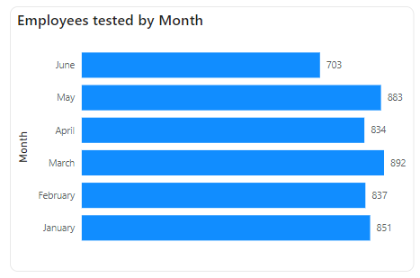

In January, we were able to test 851 employees, an additional 837 employees were tested in February. The highest number of employees (892) were tested in March, followed by May with 883 employees tested. 834 employees were tested in the month of April, and the least number of employees (703) were tested in June to round up the wellness exercise. s

**Top 5 Stress Source across Age Groups**

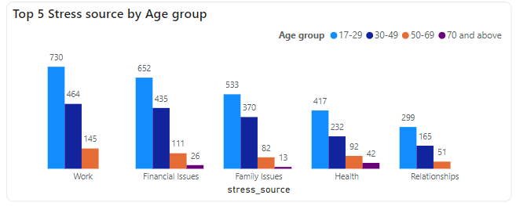

This distribution vividly indicates that a larger percentage of all age groups are stressed by work. This is followed by financial issues. It can also be seen that most employees who are 70 years and above are greatly stressed by their health, while being unbothered by work and relationships.

This data can inform targeted workload distribution, loan, and salary structure to better serve the employees.

# Symptoms and Coping mechanism Report:

This report provides a detailed analysis of the physical and emotional symptoms experienced by employees due to stress and also the methods used to cope with stress. The analysis includes: the count of employees with certain emotional symptoms, the top 7 physical symptoms based on employee count, and the top 5 coping mechanism by employee count.

**Emotional Symptoms Experienced by Employees**

Employees experienced 8 major symptoms including; anger, loneliness, fear, stress, mood swings, irritability, depression, and anxiety.

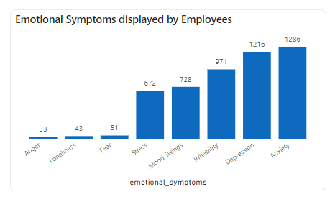

The symptom that most of the employees experienced was anxiety with a head count of 1,286, followed by depression with 1,216 employees. 971 employees show irritability, mood swings is experienced by 728 employees, with the least being anger experienced by only 33 employees.

This data highlights sensors that employers should look out for in their employees to avoid burn out or decrease in productivity.

**Physical Symptoms Experienced by Employees**

Employees experienced 9 major symptoms which include: arthritis, high blood pressure, fatigue, back pain, insomnia, headache, arthritis, loss of appetite, shortness of breath, and stomach ache. The top 7 symptoms were analyzed as they showed proper representation of the age groups.

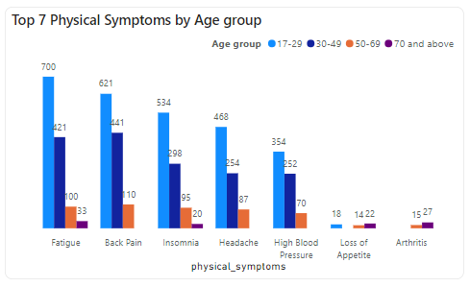

Fatigue, Back pain, Insomnia, Headache, and High blood pressure are symptoms common to a large percentage of employees in the 17-29, 30-49, as well as 50-69 age groups.

Employees in the age group 30-49 experience back pain mostly, followed by fatigue then, insomnia but, do not seem to be affected by loss of appetite or arthritis.

Employees who are 70 years and above experience fatigue and arthritis mostly. This data further points to the fact that health is a major cause of stress in employees who are 70 years and above.

**Top 5 Coping Mechanism**

* Exercise : 1,253 employees out of 5,000 employees
* Meditation : 1,171 employees out of 5,00 employees
* Food : 959 employees out of 5,00 employees
* Therapy : 716 employees out of 5,00 employees
* Hobbies : 682 employees out of 5,00 employees

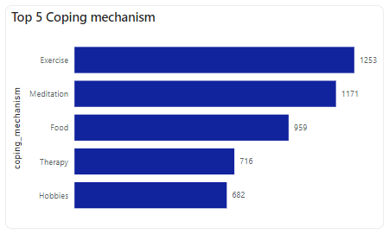

A great number of employees found exercise to be the best way to relief stress. This is closely followed by meditation, then, food. After which, we have therapy and hobbies being the least.

This data highlights key stress relief options which can be incorporated into the daily activities at the workplace to further foster healthy living among employees, and even their employers.

# Stress level Report:

This report provides a detailed analysis of the stress level score groups, focusing on key metrics such as how the groups transcend across age groups, average stress level score by daytime, groupings by sleep quality, and severity of stress.

**Average Stress Level Score by Daytime**

The stress level score of employees were analyzed in relation to the time the test was taken and it can be seen that there a close proximity between the average and, those tested in the afternoon lead with 1.360 (33.43%), followed by those tested in the evening with 1.356 (33.32%), and morning with 1.353 (33.25%).

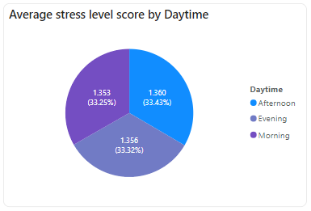

This data further lays emphasis on an insight that was earlier uncovered about less people working afternoon shifts than those in the morning shifts, and even far lesser people during the evening or night shifts. This can inform targeted stress management decisions to even out employee distribution for shifts within the organization.

**Severity of Stress Level among Employees**

The severity of stress level was categorized into three namely:

* Moderate
* Mild
* Severe

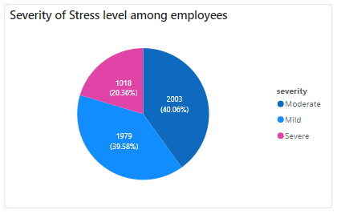

Out of all the 5,000 employees, 2,003 (40.06%) experienced moderate severity, 1,979 (39.58%) experienced mild severity, and 1,018 (20.36%) experienced severe severity.

This data shows that stress hasn’t exactly gotten to its peak amongst employees and helps us to know the best approaach to handling employees in each category for more effectiveness.

**Stress Level Score Grouping**

The stress level score of individuals were categorized into 3 using the following ranges so as to aid further analysis:

* < 1.0 – Low stress level score
* 1.0 – 1.49 – Normal stress level score
* >= 1.5 – High stress level score

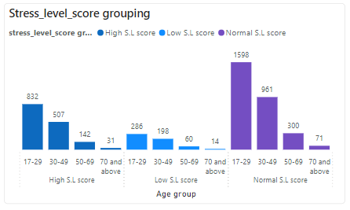

A large number of employees (2,930) had their stress level scores under the Normal group, followed by 1,512 employees in the High group, and 558 in the Low group. All these groupings are led by people in the 17-29 age group, followed by the employees in the 30-49 age group, and the least being those who are 70 years and above.

**Stress Level Score Groupings by Sleep Quality**

In the course of the analysis, we thought to check for the sleep quality of employees based on the stress level score as insomnia was one of the top 3 physical symptoms experienced by employees.

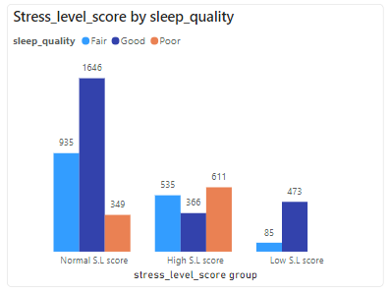

This data shows that a 1,646 employees who are under the ‘Normal’ category enjoy good sleep. In the ‘High’ category, 611 employees out of the total 1,512 sleep poorly while 535 sleep fairly, with good sleep quality (366) being the least. The employees under the ‘Low category’ enjoy good sleep mostly, with no one sleeping poorly.

**Stress Level Score by Gender**

This analysis was done to see if there is also an even distribution between the genders based on the stress level score. The data shows that more females are in the high stress level category with a count of 764 compared to the 748 for male.

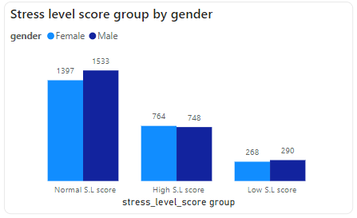

# Insights and Findings:

Mental Health Data analysis of employees reveals valuable insights into their stress sources, symptoms, coping mechanism, and stress level score.

From the distribution of employees, there is a very small margin between the number of male (2571) and female (2429) employees which indicates gender inclusion in the organization but, 764 females have a high stress level score and only 748 males fall under the same category. Also, a great deal of these employees fall within the 17-29 age group which means higher productivity without these stress levels. The employee with the highest average stress level score is Helenelizabeth Raincin with an average score of 2.25, followed by Nathanil Stoven (2.20), then, both Dennis Kupec and Jerrie Bassick had the least average score of 2.15.

From the daytime perspective, it can be seen that 52% of the workforce are on morning shift while a much lesser percentage (13%) work the night shift. The effect of this uneven distribution can be seen in the average stress level score by daytime, where 1.353 represents the morning while the evening had 1.356, and the afternoon had 1.36 which could be as a result of other factors like the weather condition.

A vast majority of employees in all age groups had work as their source of stress except employees who are 70 and above. They had their health as a major stress source, which indicates that the workload given to them was minimal and from the physical symptoms, arthritis and fatigue trumps for this age group as well.

Based on the sleep quality, 1,646 employees in the Normal Stress Level Score category were good, 935 were fair, and poor sleep had the least with 349 employees. For the High Stress Level Score category, a higher number of employees (611) suffered poor sleep quality, 535 sleep fairly, and the remaining 366 employees sleep well.

The insight drawn from this is that good sleep quality is also a way to alleviate stress in the workplace and mechanisms that can help them achieve this should be shared.

It is also important to note that majority of the employees (40.06%) suffer moderate severity, 39.58% suffer mild severity, and 20.36% suffer severe symptoms.

# Recommendations:

Based on the analysis of Mental Health data, the following strategic recommendations are proposed to alleviate stress from the workplace, and address opportunities for improvement:

1. Employees should be distributed evenly for shifts so that there is an overbearing workload for those on evening shifts as specified in the company’s data. Also, a conducive environment that can accommodate all weathers should be provided such as: installation of more air conditioners to help those on afternoon shift on days when the weather gets too hot, provision of work outfits for different weather types.
2. Employers can incorporate some of the coping mechanisms already used by employees to help the entire workforce, like a 30-minute work-out session in the mornings, meditation breaks for employees who might need it, employment of a company therapist, working with a dietician to have more healthy food options made available for employees, etc.
3. Everyone should be their brother’s keeper by watching out for any physical or emotional symptoms like anxiety, fatigue, and the likes that their colleagues might be experiencing and call the attention of a senior officer to such symptoms.
4. Since work is a major source of stress, there should be a policy in place for the maximum number of hours or shifts an employee can take over a specified period of time.
5. To help employees with financial issues, a loan system should be put in place with a feasible repayment plan so that there are little or no defaulters eventually.
6. Those who suffer poor sleep quality should be allowed to take naps between shifts to avoid a breakdown while at work.
7. Free medical checkup should be carried out for employees occasionally, especially those who are 70 and above since health is their major stress source.

# Images from the Dashboard:

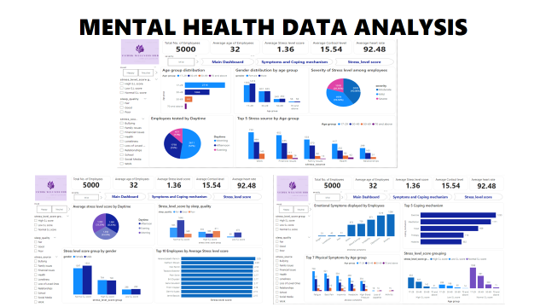

# Conclusion:

By implementing these strategic recommendations, the organization can optimize its employees mental health, alleviate stress in the workplace, enhance employee satisfaction, improve productivity, and drive sustainable growth. Continual monitoring of the stress level severity, score and symptoms of employees will be crucial in adapting strategies to maintain mild severity and productivity in the organization.

To check out the dashboard, [click here!](../Vicbuk%20Wellness%20Hub.pbix)

Tools used for this analysis: **Microsoft SQL Server** and **Microsoft PowerBI**.